2026 Galactic Gala – Event Guide and FAQs
What: A Space Force Ball in honor of Space System Command’s 5th anniversary.

Where: Disneyland Hotel - Grand Ballroom located at 1150 W. Magic Way, Anaheim, CA

When: Saturday, 8 Aug 2026.
- Cocktail Hour: 6:00 PM
- Gala Begins: 7:00 PM
Important Note: Gala admission does not include access to Disneyland parks. Park tickets must be purchased separately, with discounted tickets found here: https://disneyevent.com/ZDGH26A

Guests: You may bring guests, including:
- Spouses
- Parents
- Siblings
- Significant Others
- Friends
Guest eligibility is not limited to family relationships. All guests must purchase a ticket at the same price as the sponsoring individual.
Note: This is an adults-only event; individuals under the age of 18 are not authorized to attend.

Dress Code: Formal, Black Tie (Mess/Service Dress preferred but Optional for Military)
Dress to match the elegance of the occasion, step into an evening of class and fun:
- Formal: Tuxedo or evening gown
- Refined: Suit or cocktail dress
No wear of Disney costumes.

Transportation Options: Chartered shuttles will be available for your convenience:
Pick-up Time: 5:00 PM
Departure Time: 10:15 PM
Cost: $15 per person
Shuttle meet-up spot:
- LAAFB: Bldg 272 Parking Lot
- Fort MacArthur: Community Center back parking-lot overlooking the harbor.
Please Note:
- Shuttle seating is limited and first come, first served
- Reservations must be made when purchasing tickets online
- You are responsible for arranging base access for your guests
Important: Passengers must pre-register and indicate their preferred shuttle location when purchasing their tickets online.

Parking: If you prefer to drive:
Park at the Toy Story Parking Lot and then take the provided Disneyland event shuttle to the hotel. Shuttles are constant to allow for no-wait. Frequent return shuttles available.
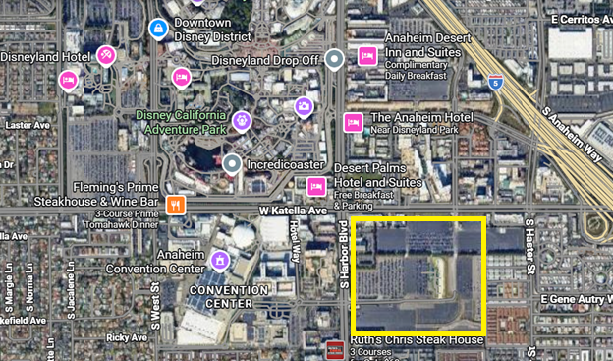

Other Parking Options;
Pixar Pals or Mickey & friends Parking Structures: $40–$60
Valet: $70 – Limited quantity available. * Contact us if you are interested in Valet.

Childcare Options: While childcare is not available at the venue, services have been arranged:
LAAFB Child Development Center (CDC)
- Open to all ages (base access required)
- Hours: 4:00 PM – 12:00 AM
- Registration deadline: July 31
- Phone: 310-653-6800
Note: Children do not need to be currently enrolled to participate.
Childcare Subsidy: Eligible families (Deployed & EFMP) may receive $40 per child subsidy (AFAS Give Parents a Break voucher). Additional steps with AFAS are required after receiving the voucher.
Vouchers may be used with:
- CDC
- Family or friends
- Independent providers
To request assistance, contact your:
- MFRC
- Chaplain
- First Sergeant

Lodging: Enhance your experience with an overnight stay:
- Hotel Room Blocks: https://disneyevent.com/ZDGH26A
  - Button at the top right corner of the website

- Disneyland Good Neighbor Hotels: https://disneyland.disney.go.com/hotels/good-neighbor/

Questions: For any additional questions or concerns: please contact:
Conor Medeiros, media@galacticemporium.org
Eric Catlett, president@galacticemporium.org
Phone: (310) 224-4551

